1. **Major Theories in Peace and Conflict Studies**

**Speaker: Dr. Marije Luitjens,** Vrije Universiteit Amsterdam (The Netherlands)

**Date: 05.03.2024, 17.30-19.00**

**Please register at** [**https://forms.office.com/e/wXWwWG4fBm**](https://forms.office.com/e/wXWwWG4fBm)

**Dr. Marije Luitjens** is a peace and conflict scholar at the VU, Amsterdam. She focuses her research contemporary understandings of peace, and as such in the increasing complexity of peace practices in relation to the changing nature of warfare. During her PhD she developed an analytical tool, the Peace System Analysis, which aims to unpack this increasing complexity, in order to design more sustainable peace practices. Marije has a background in anthropology and consequently conducts ethnographic research, among others on gang conflict in Honduras and Medellín, or on the aftermath of the Srebrenica genocide in Bosnia Herzegovina.

**Date: 05.03.2024, 17.30-19.00**

**Please register at** [**https://forms.office.com/e/wXWwWG4fBm**](https://forms.office.com/e/wXWwWG4fBm)

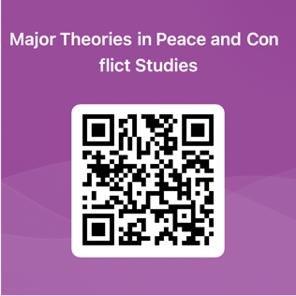

**2.**

**Inclusive peace: the Role of NGOs and Civil Society**

Guest Speaker: **Nicholas Duncan Ross,** Inclusive Peace, <https://www.inclusivepeace.org/team-member/nick-ross/>

**Nicholas Duncan Ross** is a researcher at Inclusive Peace, where he focuses on civil society support and research related to inclusion in peace and democratization processes. Nick has extensive experience as a researcher and consultant in the field of peacebuilding and democratization, engaging with the United Nations, national governments, civil society, and non-state armed groups. He has previously worked at the University of Cambridge and as a researcher at the Inclusive Peace and Transition Initiative. He has led or co-led projects in Myanmar on behalf of the Joint Peace Fund, the Australian Department of Foreign Affairs and Trade, and several civil society organizations.

**Date: March 11, 2024, 9.30-11.00 h.**

Registration: <https://forms.office.com/e/K9AVmzFrit>

3. **Rebuilding Societies after Conflict: Post-Conflict Reconstruction and Reconciliation**

**Speaker: Dr. Josh Maiyo**, United States International University – Africa, Kenya

**Dr Josh Maiyo**, Assistant Professor at United States International University - Africa, Kenya, is an experienced empirical researcher, lecturer, public speaker, and facilitator on African affairs, specializing, among others, in the Suitability of International Justice in Conflict Resolution.

**Date: 21.03, 2024, 17.00-18.30**

**Registration:** https://forms.office.com/e/bCut0VHXSP

